Drop down menu
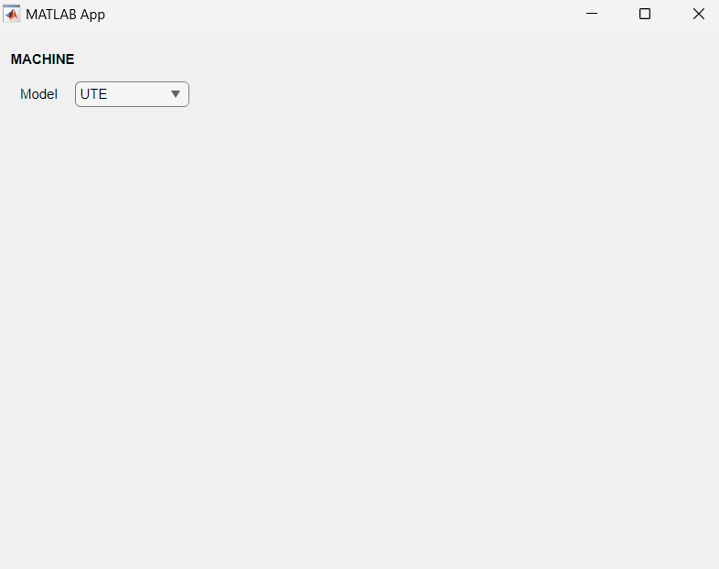

% Code that executes after component creation
function startupFcn(app)

% Call the method to read Excel data
[dropdownOptions, columnExists] = app.readExcelData();

if columnExists
% Update the dropdown component's items
app.ModelDropDown.Items = dropdownOptions;
else
% Handle the case where the 'Model' column does not exist
disp('Column "Model" does not exist in the specified sheet.');
end
end

function [dropdownOptions, columnExists] = readExcelData(app)
% Define the path to your Excel file
excelFilePath = 'C:\Users\BlossomFernandez\GB AUTO GROUP PTY LIMITED\DVT - Document\Projects\Simulink & MATLAB\Projects\APP_Fuse\Fuse_GUI.xlsx';

% Define the sheet name
sheetName = 'MachinesOnSite';

% Read the header from the second row
headerData = readcell(excelFilePath, 'Sheet', sheetName, 'Range', 'A2:X2');

% Read the actual data starting from the third row
data = readtable(excelFilePath, 'Sheet', sheetName, 'Range', 'A3:X1000'); % Adjust range as needed

% Assign column names to the table
data.Properties.VariableNames = headerData; % Assign the column names

% Check if the 'Model' column exists
columnExists = ismember('Model', data.Properties.VariableNames);

% to convert dropdownOptions to a cell array before it has been defined. To ensure that the readExcelData function works correctly, you need to handle the case where the 'Model' column exists and where it does not, and you must define dropdownOptions before trying to convert it.
if columnExists
dropdownOptions = data.Model; % Access the 'Model' column

% Remove empty entries
dropdownOptions = dropdownOptions(~cellfun('isempty', dropdownOptions));
% Convert to cell array if needed
if ~iscell(dropdownOptions)
dropdownOptions = cellstr(dropdownOptions);
end
else
dropdownOptions = {};
end

Indexing machine manufacturer
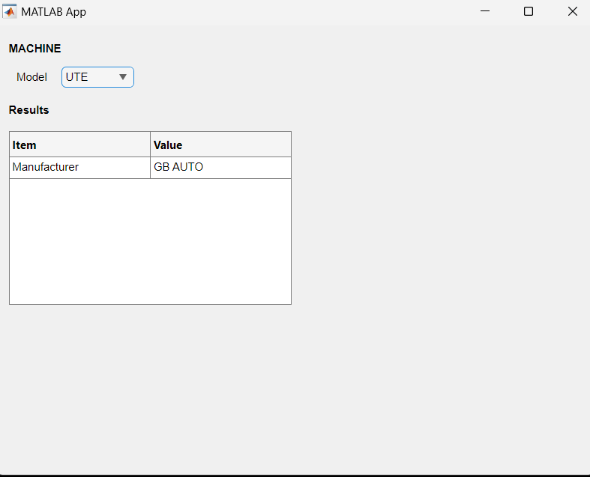
% Value changed function: ModelDropDown
function ModelDropDownValueChanged(app, event)

%Model name
selectedModel = app.ModelDropDown.Value;

%Model column data

excelFilePath = 'C:\Users\BlossomFernandez\GB AUTO GROUP PTY LIMITED\DVT - Document\Projects\Simulink & MATLAB\Projects\APP_Fuse\Fuse_GUI.xlsx';

% Define the sheet name
sheetName = 'MachinesOnSite';

% Read the header from the second row
headerData = readcell(excelFilePath, 'Sheet', sheetName, 'Range', 'A2:X2');

% Read the actual data starting from the third row
data = readtable(excelFilePath, 'Sheet', sheetName, 'Range', 'A2:X1000'); % Adjust range as needed

% Assign column names to the table
data.Properties.VariableNames = headerData; % Assign the column names

% Access the 'Model' column
modelColumn = data.Model;

% Perform index matching
rowIndex = find(ismember(modelColumn, selectedModel), 1);

if ~isempty(rowIndex)
% Specify the column you want to extract the value from
columnName = 'Manufacturer'; % Replace with your actual column name

if ismember(columnName, headerData)

% Extract the value from the specified column and row
selectedValue = data{rowIndex, columnName};

% Ensure selectedModel and selectedValue are character arrays (strings)

if ~ischar(selectedValue)
selectedValue = char(selectedValue);
end

% Now populate the table with the selectedModel and selectedValue
app.UITable.Data = {columnName, selectedValue}; % Populate the table
else
disp(['Column ', columnName, ' does not exist in the data.']);
end
else
% Handle case where no match is found
disp('No matching data found.');
end

end
end

How to display multiple rows
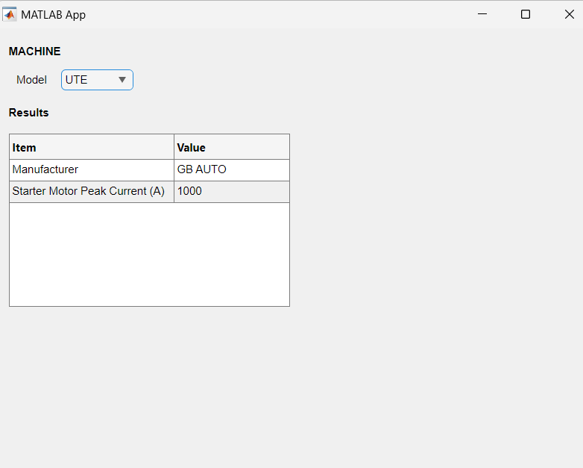

%% TO DISPLAY MANUFACTURER AND CRANKING CURRENT %%

% Get selected model from the dropdown
selectedModel = app.ModelDropDown.Value;

% Excel file path and sheet name
excelFilePath = 'C:\Users\BlossomFernandez\GB AUTO GROUP PTY LIMITED\DVT - Document\Projects\Simulink & MATLAB\Projects\APP_Fuse\Fuse_GUI.xlsx';
sheetName = 'MachinesOnSite';

% Read header and data from Excel
headerData = readcell(excelFilePath, 'Sheet', sheetName, 'Range', 'A2:X2');
data = readtable(excelFilePath, 'Sheet', sheetName, 'Range', 'A3:X1000'); % Starting from row 3

% Clean headers by removing line breaks and extra whitespace
cleanedHeaderData = regexprep(headerData, '[\n\r]+', ''); % Remove line breaks
cleanedHeaderData = strtrim(cleanedHeaderData); % Trim leading/trailing spaces

% Assign cleaned column names to the table
data.Properties.VariableNames = cleanedHeaderData;

% Check if 'Model', 'Manufacturer', and 'Starter Motor Peak Current (A)' columns exist
if ismember('Model', cleanedHeaderData) && ismember('Manufacturer', cleanedHeaderData) && ismember('Starter Motor Peak Current (A)', cleanedHeaderData)

% Access the 'Model' column
modelColumn = data.Model;

% Perform index matching to find the selected model
rowIndex = find(ismember(modelColumn, selectedModel), 1);

if ~isempty(rowIndex)
% Extract values for Manufacturer and Cranking Current
ManufacturerColumnName = 'Manufacturer';
CrankingCurrentColumnName = 'Starter Motor Peak Current (A)';
selectedValue1 = data{rowIndex, ManufacturerColumnName};
selectedValue2 = data{rowIndex, CrankingCurrentColumnName};

% Convert values to character arrays if necessary
if isnumeric(selectedValue1)
selectedValue1 = num2str(selectedValue1);
end
if isnumeric(selectedValue2)
selectedValue2 = num2str(selectedValue2);
end

% Ensure values are valid characters for UITable
selectedValue1 = char(selectedValue1);
selectedValue2 = char(selectedValue2);

% Prepare table data for display
tableData = {
'Manufacturer', selectedValue1;
'Starter Motor Peak Current (A)', selectedValue2
};

% Set the UITable Data
app.UITable.Data = tableData;

else
disp('No matching data found for the selected model.');
end
else
disp('One or more required columns (Model, Manufacturer, Starter Motor Peak Current (A)) do not exist.');
end

Displaying after logical comparison
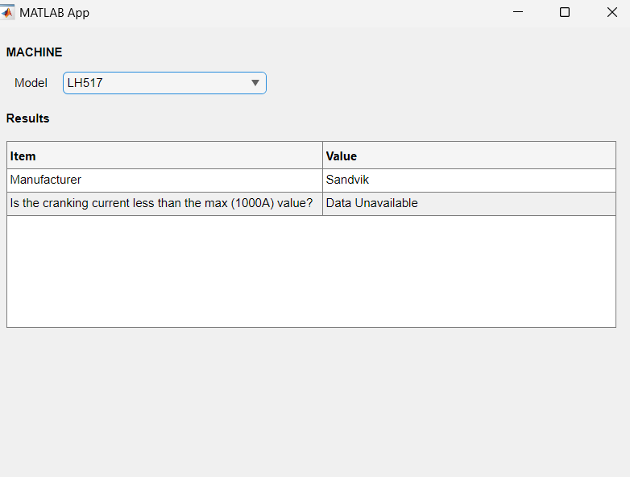
%% TO DISPLAY MANUFACTURER AND CRANKING CURRENT %%

% Get selected model from the dropdown
selectedModel = app.ModelDropDown.Value;

% Excel file path and sheet name
excelFilePath = 'C:\Users\BlossomFernandez\GB AUTO GROUP PTY LIMITED\DVT - Document\Projects\Simulink & MATLAB\Projects\APP_Fuse\Fuse_GUI.xlsx';
sheetName = 'MachinesOnSite';

% Read header and data from Excel
headerData = readcell(excelFilePath, 'Sheet', sheetName, 'Range', 'A2:X2');
data = readtable(excelFilePath, 'Sheet', sheetName, 'Range', 'A3:X1000'); % Starting from row 3

% Clean headers by removing line breaks and extra whitespace
cleanedHeaderData = regexprep(headerData, '[\n\r]+', ''); % Remove line breaks
cleanedHeaderData = strtrim(cleanedHeaderData); % Trim leading/trailing spaces

% Assign cleaned column names to the table
data.Properties.VariableNames = cleanedHeaderData;

% Check if 'Model', 'Manufacturer', and 'Starter Motor Peak Current (A)' columns exist
if ismember('Model', cleanedHeaderData) && ismember('Manufacturer', cleanedHeaderData) && ismember('Starter Motor Peak Current (A)', cleanedHeaderData)

% Access the 'Model' column
modelColumn = data.Model;

% Perform index matching to find the selected model
rowIndex = find(ismember(modelColumn, selectedModel), 1);

if ~isempty(rowIndex)
% Extract values for Manufacturer and Cranking Current
ManufacturerColumnName = 'Manufacturer';
CrankingCurrentColumnName = 'Starter Motor Peak Current (A)';

% Extract values for 'Manufacturer' and 'Starter Motor Peak Current (A)'
selectedValue1 = data{rowIndex, ManufacturerColumnName}; % Manufacturer
selectedValue2 = data{rowIndex, CrankingCurrentColumnName}; % Cranking current

% Check if selected values are empty or 'TBC' and set to 'Data Unavailable' if true
if isempty(selectedValue1) || strcmp(selectedValue1, 'TBC')
selectedValue1 = 'Data Unavailable';
end

if isempty(selectedValue2) || strcmp(selectedValue2, 'TBC')
selectedValue2 = 'Data Unavailable';
end

% Check if cranking current is less than 1000A or invalid
if strcmp(selectedValue2, 'Data Unavailable')
selectedValue3 = 'Data Unavailable';
elseif str2double(selectedValue2) <= 1000
selectedValue3 = 'YES';
else
selectedValue3 = 'NO';
end

% Convert values to character arrays if necessary
if isnumeric(selectedValue1)
selectedValue1 = num2str(selectedValue1);
end
if isnumeric(selectedValue2)
selectedValue2 = num2str(selectedValue2);
end
if isnumeric(selectedValue3)
selectedValue3 = num2str(selectedValue3);
end

% Ensure values are valid characters for UITable
selectedValue1 = char(selectedValue1);
selectedValue2 = char(selectedValue2);
selectedValue3 = char(selectedValue3);

% Prepare table data for display
tableData = {
'Manufacturer', selectedValue1;
%'Starter Motor Peak Current (A)', selectedValue2;
'Is the cranking current less than the max (1000A) value?', selectedValue3
};

% Set the UITable Data
app.UITable.Data = tableData;

else
disp('No matching data found for the selected model.');
end
else
disp('One or more required columns (Model, Manufacturer, Starter Motor Peak Current (A)) do not exist.');
end

Simplified excel representation and logical results

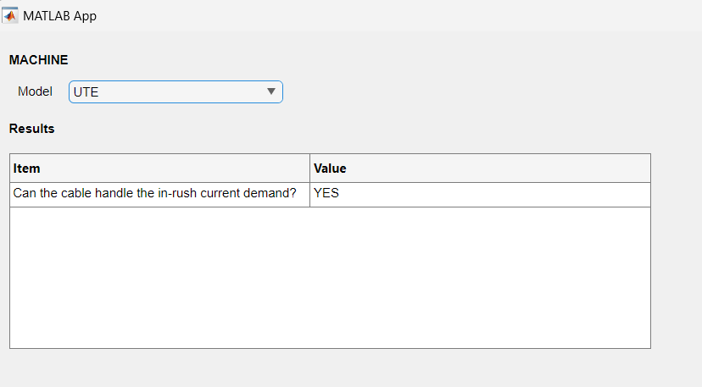
%Model name
selectedModel = app.ModelDropDown.Value;

%Model column data

excelFilePath = 'C:\Users\BlossomFernandez\GB AUTO GROUP PTY LIMITED\DVT - Document\Projects\Simulink & MATLAB\Projects\APP_Fuse\Fuse_GUI.xlsx';

% Define the sheet name
sheetName = 'MachinesOnSite';

% Read the header from the second row
headerDataMachinesOnSite = readcell(excelFilePath, 'Sheet', sheetName, 'Range', 'A2:X2');

% Read the actual data starting from the third row
dataMachinesOnSite = readtable(excelFilePath, 'Sheet', sheetName, 'Range', 'A2:X1000'); % Adjust range as needed

% Clean headers by removing line breaks and extra whitespace
cleanedHeaderDataMachinesOnSite = regexprep(headerDataMachinesOnSite, '[\n\r]+', ''); % Remove line breaks
cleanedHeaderDataMachinesOnSite = strtrim(cleanedHeaderDataMachinesOnSite); % Trim leading/trailing spaces

disp(cleanedHeaderDataMachinesOnSite);
% Assign cleaned column names to the table
dataMachinesOnSite.Properties.VariableNames = cleanedHeaderDataMachinesOnSite;

% Access the 'Model' column
modelColumn = dataMachinesOnSite.Model;

% Perform index matching to find the selected model
rowIndexMachinesOnSite = find(ismember(modelColumn, selectedModel), 1);

if ~isempty(rowIndexMachinesOnSite)

% Find Parameter columns
CrankingCurrentColumnName = 'Starter Motor Peak Current (A)';
CrankingTimeColumnName = 'Cranking time (s)';
CableSizeColumnName = 'Cable Size(mm2)';

%Extract Value in the respective column
CrankingCurrentValue = dataMachinesOnSite{rowIndexMachinesOnSite, CrankingCurrentColumnName}; % Cranking currentat 1000A
CrankingTimeValue = dataMachinesOnSite{rowIndexMachinesOnSite, CrankingTimeColumnName}; %CrankingTime
CableSizeValue = dataMachinesOnSite{rowIndexMachinesOnSite,CableSizeColumnName}; %CableSize

%Formula for calcualting Peak/short circuit current carrying capability (A) (time <= 5 s)

if isempty(CrankingCurrentValue) || strcmp(CrankingCurrentValue, 'TBC')|| strcmp(CrankingCurrentValue, '#N/A') || strcmp(CableSizeValue, 'TBC')|| strcmp(CableSizeValue, '#N/A') ||strcmp(CrankingTimeValue, 'TBC')|| strcmp(CrankingTimeValue, '#N/A')
CablePeakCurrentValue = 'Data Unavailable';
else
CablePeakCurrentValue = round((str2double(CrankingCurrentValue) * str2double(CableSizeValue)) / sqrt(str2double(CrankingTimeValue)), 0);

end

%YES /NO / DATA UNAVAILABLE

%Can the cable handle the in-rush current demand?
if strcmp(CablePeakCurrentValue, 'Data Unavailable')
CablePeakYESorNO = 'Data Unavailable';
elseif str2double(CrankingCurrentValue) <= CablePeakCurrentValue
CablePeakYESorNO = 'YES';
else
CablePeakYESorNO = 'NO';
end

tableData = {
'Can the cable handle the in-rush current demand? ',CablePeakYESorNO ;
};

% Set the UITable Data
app.UITable.Data = tableData;
end

Code without fuse matching
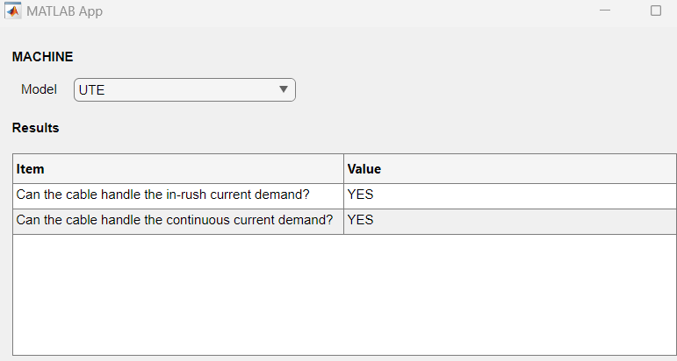

%% Model name
selectedModel = app.ModelDropDown.Value;

%% Model column data
excelFilePath = 'C:\Users\BlossomFernandez\GB AUTO GROUP PTY LIMITED\DVT - Document\Projects\Simulink & MATLAB\Projects\APP_Fuse\Fuse_GUI.xlsx';

%% Define the sheet name
% MachineOnSite Sheet
sheetNameMachinesOnSite = 'MachinesOnSite';
% Fuse Library Sheet
sheetNameFuseLibrary = 'Fuse_Library';

%% Read the header from the second row
% MachineOnSite Sheet
headerDataMachinesOnSite = readcell(excelFilePath, 'Sheet', sheetNameMachinesOnSite, 'Range', 'A2:X2');
% Fuse Library Sheet
headerDataFuseLibrary = readcell(excelFilePath, 'Sheet', sheetNameFuseLibrary, 'Range', 'A1:K1');

%% Read the actual data starting from the third row
% MachineOnSite Sheet
dataMachinesOnSite = readtable(excelFilePath, 'Sheet', sheetNameMachinesOnSite, 'Range', 'A3:X1000'); % Adjust range as needed
% Fuse Library Sheet
dataFuseLibrary = readtable(excelFilePath, 'Sheet', sheetNameFuseLibrary, 'Range', 'A2:K20'); % Adjust range as needed

%% Clean headers by removing line breaks and extra whitespace
% MachineOnSite Sheet
cleanedHeaderDataMachinesOnSite = regexprep(headerDataMachinesOnSite, '[\n\r]+', ''); % Remove line breaks
cleanedHeaderDataMachinesOnSite = strtrim(cleanedHeaderDataMachinesOnSite); % Trim leading/trailing spaces
% Fuse Library Sheet
cleanedHeaderDataFuseLibrary = regexprep(headerDataFuseLibrary, '[\n\r]+', ''); % Remove line breaks
cleanedHeaderDataFuseLibrary = strtrim(cleanedHeaderDataFuseLibrary); % Trim leading/trailing spaces

%% Assign cleaned column names to the table
% MachineOnSite Sheet
dataMachinesOnSite.Properties.VariableNames = cleanedHeaderDataMachinesOnSite;
% Fuse Library Sheet
dataFuseLibrary.Properties.VariableNames = cleanedHeaderDataFuseLibrary;

%% Access the Column
% MachineOnSite Sheet
modelColumn = dataMachinesOnSite.Model;

%% Perform index matching to find the selected model
rowIndexMachinesOnSite = find(ismember(modelColumn, selectedModel), 1);

if ~isempty(rowIndexMachinesOnSite)
%% Assign Column Names from data table
CrankingCurrentColumnName = 'Starter Motor Peak Current (A)';
CrankingTimeColumnName = 'Cranking time (s)';
CableSizeColumnName = 'Cable Size(mm2)';
AlternatorContinuousCurrentColumnName = 'Alternator Continuous Current (A)';
CableContinuousCurrentColumnName = 'Continuous Current (A)';

%% Assign Data
FusingSafetyCurrentFactor = 125/100;

%% Extract Value in the respective column
CrankingCurrentValue = dataMachinesOnSite{rowIndexMachinesOnSite, CrankingCurrentColumnName}; % Cranking current at 1000A
CrankingTimeValue = dataMachinesOnSite{rowIndexMachinesOnSite, CrankingTimeColumnName}; % Cranking Time
CableSizeValue = dataMachinesOnSite{rowIndexMachinesOnSite, CableSizeColumnName}; % Cable Size
AlternatorContinuousCurrentValue = dataMachinesOnSite{rowIndexMachinesOnSite, AlternatorContinuousCurrentColumnName }; % Alternator Continuous Current
CableContinuousCurrentValue = dataMachinesOnSite{rowIndexMachinesOnSite, CableContinuousCurrentColumnName }; % Cable Continuous Current

% Calculating Peak/short circuit current carrying capability (A) (time <= 5 s)
if isnan(str2double(CrankingCurrentValue)) || isnan(str2double(CableSizeValue)) || isnan(str2double(CrankingTimeValue))
CablePeakCurrentValue = 'Data Unavailable';
else
CablePeakCurrentValue = round((143 * str2double(CableSizeValue)) / sqrt(str2double(CrankingTimeValue)), 0); % K FACTOR FIX IT
end

% Ensure CrankingCurrentValue and CablePeakCurrentValue are numeric and extract from cells if needed
if iscell(CrankingCurrentValue)
CrankingCurrentValue = CrankingCurrentValue{:}; % Extract the value from the cell
end

if iscell(CablePeakCurrentValue)
CablePeakCurrentValue = CablePeakCurrentValue{:}; % Extract the value from the cell
end

% YES / NO / DATA UNAVAILABLE / COMPARE VALUES
% Can the cable handle the in-rush current demand?
if isnan(CablePeakCurrentValue)
CablePeakLogic = 'Data Unavailable for Calculations';
elseif CrankingCurrentValue <= CablePeakCurrentValue
CablePeakLogic = 'YES';
else
CablePeakLogic = 'NO';
end

% Ensure values are numeric
if iscell(AlternatorContinuousCurrentValue)
AlternatorContinuousCurrentValue = str2double(AlternatorContinuousCurrentValue{:});
elseif ischar(AlternatorContinuousCurrentValue)
AlternatorContinuousCurrentValue = str2double(AlternatorContinuousCurrentValue);
end

if iscell(CableContinuousCurrentValue)
CableContinuousCurrentValue = str2double(CableContinuousCurrentValue{:});
elseif ischar(CableContinuousCurrentValue)
CableContinuousCurrentValue = str2double(CableContinuousCurrentValue);
end
disp(['AlternatorContinuousCurrentValue: ', num2str(AlternatorContinuousCurrentValue)]);
disp(['CableContinuousCurrentValue: ', num2str(CableContinuousCurrentValue)]);

% Can the cable handle the continuous current demand?
if isnumeric(AlternatorContinuousCurrentValue) && isnumeric(CableContinuousCurrentValue)
if AlternatorContinuousCurrentValue <= CableContinuousCurrentValue
CableContinuousCurrentLogic = 'YES';
else
CableContinuousCurrentLogic = 'NO';
end
else
CableContinuousCurrentLogic = 'Data Unavailable for Calculations';
end

% Set UITable Data
tableData = {
'Can the cable handle the in-rush current demand?', CablePeakLogic;
'Can the cable handle the continuous current demand?', CableContinuousCurrentLogic;
};

app.UITable.Data = tableData;
end

Code with data types and colour
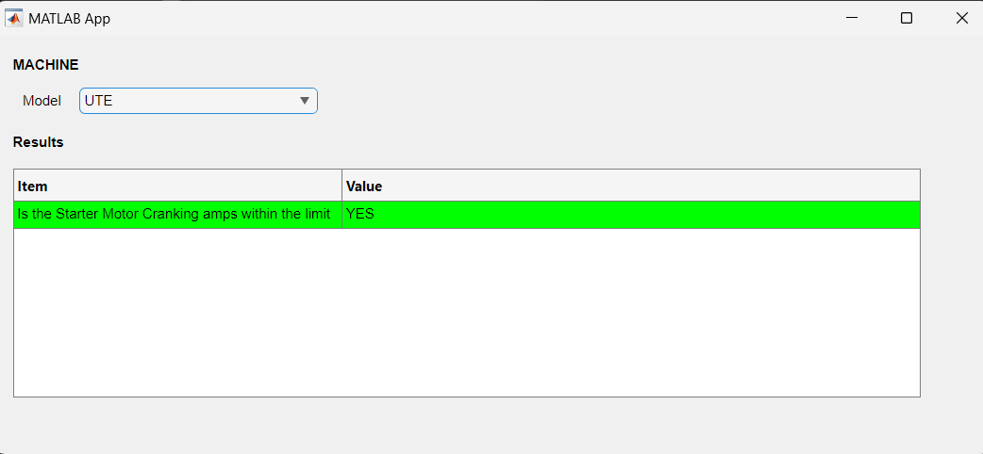

% Value changed function: ModelDropDown
function ModelDropDownValueChanged(app, event)
%% TO DISPLAY MANUFACTURER AND CRANKING CURRENT %%
% Model name
selectedModel = app.ModelDropDown.Value;

%% Model column data
excelFilePath = 'C:\Users\BlossomFernandez\GB AUTO GROUP PTY LIMITED\DVT - Document\Projects\Simulink & MATLAB\Projects\APP_Fuse\Fuse_GUI.xlsx';

%% Define the sheet name
% MachineOnSite Sheet
sheetNameMachinesOnSite = 'MachinesOnSite';
% Fuse Library Sheet
sheetNameFuseLibrary = 'Fuse_Library';

%% Read the header from the second row
% MachineOnSite Sheet
headerDataMachinesOnSite = readcell(excelFilePath, 'Sheet', sheetNameMachinesOnSite, 'Range', 'A2:X2');
% Fuse Library Sheet
headerDataFuseLibrary = readcell(excelFilePath, 'Sheet', sheetNameFuseLibrary, 'Range', 'A1:K1');

%% Read the actual data starting from the third row
% MachineOnSite Sheet
dataMachinesOnSite = readtable(excelFilePath, 'Sheet', sheetNameMachinesOnSite, 'Range', 'A3:X1000'); % Adjust range as needed
% Fuse Library Sheet
dataFuseLibrary = readtable(excelFilePath, 'Sheet', sheetNameFuseLibrary, 'Range', 'A2:K20'); % Adjust range as needed

%% Clean headers by removing line breaks and extra whitespace
% MachineOnSite Sheet
cleanedHeaderDataMachinesOnSite = regexprep(headerDataMachinesOnSite, '[\n\r]+', ''); % Remove line breaks
cleanedHeaderDataMachinesOnSite = strtrim(cleanedHeaderDataMachinesOnSite); % Trim leading/trailing spaces
% Fuse Library Sheet
cleanedHeaderDataFuseLibrary = regexprep(headerDataFuseLibrary, '[\n\r]+', ''); % Remove line breaks
cleanedHeaderDataFuseLibrary = strtrim(cleanedHeaderDataFuseLibrary); % Trim leading/trailing spaces

%% Assign cleaned column names to the table
% MachineOnSite Sheet
dataMachinesOnSite.Properties.VariableNames = cleanedHeaderDataMachinesOnSite;
% Fuse Library Sheet
dataFuseLibrary.Properties.VariableNames = cleanedHeaderDataFuseLibrary;

%% Access the Column
% MachineOnSite Sheet
modelColumn = dataMachinesOnSite.Model;

%% Perform index matching to find the selected model
rowIndexMachinesOnSite = find(ismember(modelColumn, selectedModel), 1);

% Initialize selectedValue5
CrankingAmpsHighorLow = 'Data Unavailable'; % Default value

if ~isempty(rowIndexMachinesOnSite)
%% Assign Column Names from data table
StarterMotorCrankingCurrentColumnName = 'Starter Motor Peak Current (A)';
CrankingTimeColumnName = 'Cranking time (s)';
CableSizeColumnName = 'Cable Size(mm2)';
AlternatorContinuousCurrentColumnName = 'Alternator Continuous Current (A)';
CableContinuousCurrentColumnName = 'Continuous Current (A)';

%% Assign Data
FusingSafetyCurrentFactor = 125/100;

% Extract the values in the respective column
StarterMotorCrankingCurrentValue = dataMachinesOnSite{rowIndexMachinesOnSite, StarterMotorCrankingCurrentColumnName}; % Cranking current at 1000A
CrankingTimeValue = dataMachinesOnSite{rowIndexMachinesOnSite, CrankingTimeColumnName}; % Cranking Time
CableSizeValue = dataMachinesOnSite{rowIndexMachinesOnSite, CableSizeColumnName}; % Cable Size
AlternatorContinuousCurrentValue = dataMachinesOnSite{rowIndexMachinesOnSite, AlternatorContinuousCurrentColumnName}; % Alternator Continuous Current
CableContinuousCurrentValue = dataMachinesOnSite{rowIndexMachinesOnSite, CableContinuousCurrentColumnName}; % Cable Continuous Current

% Apply the function to convert values
StarterMotorCrankingCurrentValue = app.convertValue(StarterMotorCrankingCurrentValue);
CrankingTimeValue = app.convertValue(CrankingTimeValue);
CableSizeValue = app.convertValue(CableSizeValue);
AlternatorContinuousCurrentValue = app.convertValue(AlternatorContinuousCurrentValue);
CableContinuousCurrentValue = app.convertValue(CableContinuousCurrentValue);

% Debugging: Print the class of the converted value
disp(['Class of StarterMotorCrankingCurrentValue: ', class(StarterMotorCrankingCurrentValue)]);
disp(['StarterMotorCrankingCurrentValue: ', num2str(StarterMotorCrankingCurrentValue)]);

% Check if cranking current is 'Data Unavailable' or another string like 'TBC'
if ischar(StarterMotorCrankingCurrentValue) || isstring(StarterMotorCrankingCurrentValue)
% Handle cases where the value is 'Data Unavailable', 'TBC', etc.
if strcmp(StarterMotorCrankingCurrentValue, 'Data Unavailable') || strcmp(StarterMotorCrankingCurrentValue, 'TBC')
CrankingAmpsHighorLow = 'Data Unavailable';
end
elseif isnumeric(StarterMotorCrankingCurrentValue)

% If it's numeric, compare it
if StarterMotorCrankingCurrentValue <= 1000
CrankingAmpsHighorLow = 'YES'; % Cranking current is <= 1000A
else
CrankingAmpsHighorLow = 'NO, Cranking amps over the limit, replace the starter motor'; % Cranking current is greater than 1000A
end
else
% Handle unexpected data types
CrankingAmpsHighorLow = 'Invalid Data';
end
end

% Debugging: Print selectedValue5
disp(['Is cranking current <= 1000A: ', CrankingAmpsHighorLow]);

% Display converted values (use num2str for numeric values)
disp(['StarterMotorCrankingCurrentValue: ', num2str(StarterMotorCrankingCurrentValue)]);
disp(['CrankingTimeValue: ', num2str(CrankingTimeValue)]);
disp(['CableSizeValue: ', num2str(CableSizeValue)]);
disp(['AlternatorContinuousCurrentValue: ', num2str(AlternatorContinuousCurrentValue)]);
disp(['CableContinuousCurrentValue: ', num2str(CableContinuousCurrentValue)]);

%% Set UITable Data
tableData = {
% You can populate the table data here
'Is the Starter Motor Cranking amps within the limit', CrankingAmpsHighorLow;

};

app.UITable.Data = tableData;

% Define the color matrix to match the size of tableData
% For simplicity, assume the same color applies to all cells based on `selectedValue5`
colorMatrix = repmat({'white'}, size(tableData)); % Default to white

% Define colors based on selectedValue5
switch CrankingAmpsHighorLow
case 'Data Unavailable'
colorMatrix(:) = {'yellow'};
case 'YES'
colorMatrix(:) = {'green'};
case 'NO, Cranking amps over the limit, replace the starter motor'
colorMatrix(:) = {'red'};
case 'Invalid Data'
colorMatrix(:) = {'gray'};
otherwise
colorMatrix(:) = {'white'}; % Default color
end

% Update the UITable Data
app.UITable.Data = tableData;

% Apply colors to the UITable
app.UITable.BackgroundColor = colorMatrix;
end

% Function to check type and convert values
function output = convertValue(~, val)
if iscell(val) % If it's a cell array
val = val{1}; % Extract the first element
end

% Handle different data types
if isnumeric(val)
output = val; % If numeric, leave it as is
elseif ischar(val) || isstring(val)
output = str2double(val); % Convert char or string to numeric if possible
if isnan(output)
output = string(val); % If conversion to numeric fails, convert to string
end
else
output = val; % If some other type, leave it unchanged (or handle as needed)
end

end
end

Menu 1 done with colour
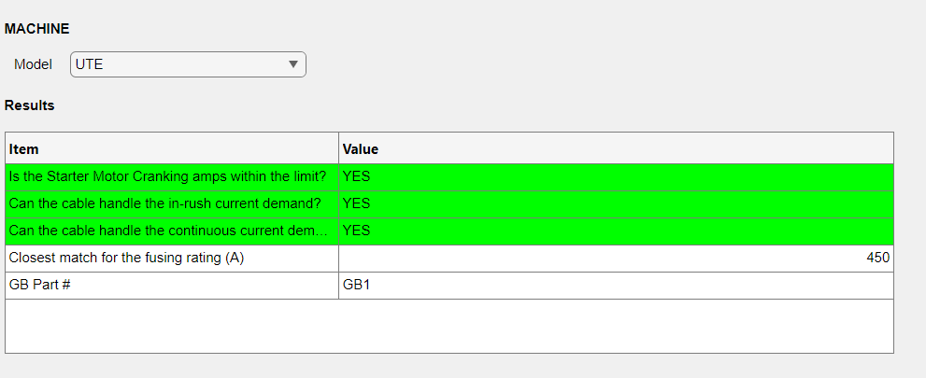

% Value changed function: ModelDropDown
function ModelDropDownValueChanged(app, event)
%% TO DISPLAY MANUFACTURER AND CRANKING CURRENT %%
% Model name
selectedModel = app.ModelDropDown.Value;

%% Model column data
excelFilePath = 'C:\Users\BlossomFernandez\GB AUTO GROUP PTY LIMITED\DVT - Document\Projects\Simulink & MATLAB\Projects\APP_Fuse\Fuse_GUI.xlsx';

%% Define the sheet name
% MachineOnSite Sheet
sheetNameMachinesOnSite = 'MachinesOnSite';
% Fuse Library Sheet
sheetNameFuseLibrary = 'Fuse_Library';

%% Read the header from the second row
% MachineOnSite Sheet
headerDataMachinesOnSite = readcell(excelFilePath, 'Sheet', sheetNameMachinesOnSite, 'Range', 'A2:X2');
% Fuse Library Sheet
headerDataFuseLibrary = readcell(excelFilePath, 'Sheet', sheetNameFuseLibrary, 'Range', 'A1:K1');

%% Read the actual data starting from the third row
% MachineOnSite Sheet
dataMachinesOnSite = readtable(excelFilePath, 'Sheet', sheetNameMachinesOnSite, 'Range', 'A3:X1000'); % Adjust range as needed
% Fuse Library Sheet
dataFuseLibrary = readtable(excelFilePath, 'Sheet', sheetNameFuseLibrary, 'Range', 'A2:K20'); % Adjust range as needed

%% Clean headers by removing line breaks and extra whitespace
% MachineOnSite Sheet
cleanedHeaderDataMachinesOnSite = regexprep(headerDataMachinesOnSite, '[\n\r]+', ''); % Remove line breaks
cleanedHeaderDataMachinesOnSite = strtrim(cleanedHeaderDataMachinesOnSite); % Trim leading/trailing spaces
% Fuse Library Sheet
cleanedHeaderDataFuseLibrary = regexprep(headerDataFuseLibrary, '[\n\r]+', ''); % Remove line breaks
cleanedHeaderDataFuseLibrary = strtrim(cleanedHeaderDataFuseLibrary); % Trim leading/trailing spaces

%% Assign cleaned column names to the table
% MachineOnSite Sheet
dataMachinesOnSite.Properties.VariableNames = cleanedHeaderDataMachinesOnSite;
% Fuse Library Sheet
dataFuseLibrary.Properties.VariableNames = cleanedHeaderDataFuseLibrary;

%% Access the Column
% MachineOnSite Sheet
modelColumn = dataMachinesOnSite.Model;

% Fuse Library Sheet
FuseRatingColumn = dataFuseLibrary.('Current rating (A)') ;
ThermalEnergyColumn = dataFuseLibrary.('I2t (A2s)');
GBPartNumberColumn = dataFuseLibrary.('GB PART #');

%% Perform index matching to find the selected model
rowIndexMachinesOnSite = find(ismember(modelColumn, selectedModel), 1);

%% Initialize Values
CrankingAmpsHighorLow = 'Data Unavailable'; % Default value

if ~isempty(rowIndexMachinesOnSite)
%% Assign Column Names from data table
StarterMotorCrankingCurrentColumnName = 'Starter Motor Peak Current (A)';
CrankingTimeColumnName = 'Cranking time (s)';
CableSizeColumnName = 'Cable Size(mm2)';
AlternatorContinuousCurrentColumnName = 'Alternator Continuous Current (A)';
CableContinuousCurrentColumnName = 'Continuous Current (A)';

%% Assign Data
FusingSafetyCurrentFactor = 125/100;
KFactorCopper = 143;

%% Extract the values in the respective column
StarterMotorCrankingCurrentValue = dataMachinesOnSite{rowIndexMachinesOnSite, StarterMotorCrankingCurrentColumnName}; % Cranking current at 1000A
CrankingTimeValue = dataMachinesOnSite{rowIndexMachinesOnSite, CrankingTimeColumnName}; % Cranking Time
CableSizeValue = dataMachinesOnSite{rowIndexMachinesOnSite, CableSizeColumnName}; % Cable Size
AlternatorContinuousCurrentValue = dataMachinesOnSite{rowIndexMachinesOnSite, AlternatorContinuousCurrentColumnName}; % Alternator Continuous Current
CableContinuousCurrentValue = dataMachinesOnSite{rowIndexMachinesOnSite, CableContinuousCurrentColumnName}; % Cable Continuous Current

%% Apply the function to convert values
StarterMotorCrankingCurrentValue = app.convertValue(StarterMotorCrankingCurrentValue);
CrankingTimeValue = app.convertValue(CrankingTimeValue);
CableSizeValue = app.convertValue(CableSizeValue);
AlternatorContinuousCurrentValue = app.convertValue(AlternatorContinuousCurrentValue);
CableContinuousCurrentValue = app.convertValue(CableContinuousCurrentValue);
GBPartNumberColumn = app.convertValue(GBPartNumberColumn);

%% Debugging: Print the class of the converted value
% disp(['Class of StarterMotorCrankingCurrentValue: ', class(StarterMotorCrankingCurrentValue)]);
% disp(['Class of CrankingTimeValue: ', class(CrankingTimeValue)]);
% disp(['Class of CableSizeValue: ', class(CableSizeValue)]);
% disp(['Class of AlternatorContinuousCurrentValue: ', class(AlternatorContinuousCurrentValue)]);
% disp(['Class of CableContinuousCurrentValue: ', class(CableContinuousCurrentValue)]);

%% Check if parameter is 'Data Unavailable' or another string like 'TBC'

%Is the cranking current less than the max (1000A) value?

if ischar(StarterMotorCrankingCurrentValue) || isstring(StarterMotorCrankingCurrentValue)
% Handle cases where the value is 'Data Unavailable', 'TBC', etc.
if strcmp(StarterMotorCrankingCurrentValue, 'Data Unavailable') || strcmp(StarterMotorCrankingCurrentValue, 'TBC')
CrankingAmpsHighorLow = 'Data Unavailable';
end
elseif isnumeric(StarterMotorCrankingCurrentValue)

% If it's numeric, compare it
if StarterMotorCrankingCurrentValue <= 1000
CrankingAmpsHighorLow = 'YES'; % Cranking current is <= 1000A
else
CrankingAmpsHighorLow = 'NO, Cranking amps over the limit, replace the starter motor'; % Cranking current is greater than 1000A
end
else
% Handle unexpected data types
CrankingAmpsHighorLow = 'Invalid Data';
end
end

%% Check if the parameter is 'Data Unavailable' or another string like 'TBC'

%Can the cable handle the in-rush current demand?

if ischar(CrankingTimeValue) || isstring(CrankingTimeValue) || ischar(CableSizeValue) || isstring(CableSizeValue)
% Handle cases where the value is 'Data Unavailable', 'TBC', etc.
if strcmp(CrankingTimeValue, 'Data Unavailable') || strcmp(CrankingTimeValue, 'TBC') || strcmp(CableSizeValue, 'Data Unavailable') || strcmp(CableSizeValue, 'TBC')

CablePeakCurrent = 'Data Unavailable';
end

elseif isnumeric(CrankingTimeValue) && isnumeric(CableSizeValue)

% If it's numeric, compare it
if CrankingTimeValue <= 5
CablePeakCurrent = ((KFactorCopper*CableSizeValue)/ sqrt (CrankingTimeValue)) ;
else
CablePeakCurrent = ['Cables unable handle peak current beyond 5s, ' ...
'investigate electrical component that needs servicing'];
end
else
% Handle unexpected data types
CablePeakCurrent = 'Invalid Data';
end

%% Can the cable handle the in-rush current demand?

if ischar(StarterMotorCrankingCurrentValue) || isstring(StarterMotorCrankingCurrentValue) || ischar(CablePeakCurrent) || isstring(CablePeakCurrent)
% Handle cases where the value is 'Data Unavailable', 'TBC', etc.
if strcmp(StarterMotorCrankingCurrentValue, 'Data Unavailable') || strcmp(StarterMotorCrankingCurrentValue, 'TBC') || strcmp(CablePeakCurrent, 'Data Unavailable') || strcmp(CablePeakCurrent, 'TBC')

CablePeakHandlingCapability = 'Data Unavailable';
end

elseif isnumeric(StarterMotorCrankingCurrentValue) && isnumeric(CablePeakCurrent)

% If it's numeric, compare it
if StarterMotorCrankingCurrentValue <= CablePeakCurrent
CablePeakHandlingCapability = 'YES';
else
CablePeakHandlingCapability = 'NO';
end
else
% Handle unexpected data types
CablePeakHandlingCapability = 'Invalid Data';
end

%% Can the cable handle the continuous current demand?

if ischar(AlternatorContinuousCurrentValue) || isstring(AlternatorContinuousCurrentValue) || ischar(CableContinuousCurrentValue) || isstring(CableContinuousCurrentValue)
% Handle cases where the value is 'Data Unavailable', 'TBC', etc.
if strcmp(AlternatorContinuousCurrentValue, 'Data Unavailable') || strcmp(AlternatorContinuousCurrentValue, 'TBC') || strcmp(CableContinuousCurrentValue, 'Data Unavailable') || strcmp(CableContinuousCurrentValue, 'TBC')

CableContiHandlingCapability = 'Data Unavailable';
end

elseif isnumeric(AlternatorContinuousCurrentValue) && isnumeric(CableContinuousCurrentValue)

% If it's numeric, compare it
if AlternatorContinuousCurrentValue <= CableContinuousCurrentValue
CableContiHandlingCapability = 'YES';
else
CableContiHandlingCapability = 'NO';
end
else
% Handle unexpected data types
CableContiHandlingCapability = 'Invalid Data';
end
%% Fuse Current Rating (A) calculation

if strcmp(CableContiHandlingCapability, 'YES')
FuseCurrentRatingCalculation = FusingSafetyCurrentFactor * CableContinuousCurrentValue;
else
FuseCurrentRatingCalculation = 'Data Unavailable';

end

%% Closest Fuse Match Calculation

% Check if FuseCurrentRating is available and numeric
if isnumeric(FuseCurrentRatingCalculation)
% Calculate the absolute difference between the Fuse options and the current rating
diff = abs(FuseRatingColumn - FuseCurrentRatingCalculation);

% Find the index of the minimum difference
[~, idx] = min(diff); %The first output is the minimum value itself. The second output is the index of that minimum value in the array.

% If an index is found, get the closest fuse match
if ~isempty(idx)
FuseClosestMatch = FuseRatingColumn(idx);
else
FuseClosestMatch = 'Data Unavailable';
end
else
FuseClosestMatch = 'Data Unavailable';
end

%% Fuse Thermal Energy Calculation

% Check if FuseCurrentRating is available and numeric
if isnumeric(StarterMotorCrankingCurrentValue) && isnumeric(CrankingTimeValue) && strcmp(CrankingAmpsHighorLow, 'YES')
% Calculate the absolute difference between the Fuse options and the current rating
RequiredThermalEnergy = (StarterMotorCrankingCurrentValue)^2 * CrankingTimeValue;
else
RequiredThermalEnergy = 'Data Unavailable';
end

%% Thermal Energy Match Calculation

if isnumeric(RequiredThermalEnergy) && isnumeric(FuseClosestMatch)
% Extract Thermal Energy Column from the table

% Perform logical indexing to filter the values
validRows = (FuseRatingColumn == FuseClosestMatch) & (ThermalEnergyColumn > RequiredThermalEnergy);

% Check if there are valid matches
matchingThermalEnergy = ThermalEnergyColumn(validRows);

if ~isempty(matchingThermalEnergy)
% Return the first match
ThermalEnergyMatch = matchingThermalEnergy(1);
else
% No valid match found
ThermalEnergyMatch = 'NO MATCH';
end
else
% If data is not available
ThermalEnergyMatch = 'Data Unavailable';
end
%% Match GB Part #

% Assume the columns are already loaded into variables:
% GBPartNumberColumn, ThermalEnergyColumn, FuseRatingColumn, ThermalEnergyMatch, FuseClosestMatch

% Find rows where both conditions are true
matchingRows = (ThermalEnergyColumn == ThermalEnergyMatch) & (FuseRatingColumn == FuseClosestMatch);

% Find the first matching row
rowIndex = find(matchingRows, 1);

% Retrieve the corresponding value from GBPartNumberColumn
if ~isempty(rowIndex)
GBPartNumberValue = GBPartNumberColumn(rowIndex);
else
GBPartNumberValue = 'Data Unavailable'; % Handle the case when no match is found
end

% Display the result
disp(['GBPartNumberValue: ', num2str(GBPartNumberValue)]);

%% Debugging:
disp(['FuseClosestMatch: ', num2str(FuseClosestMatch)]);
disp(['RequiredThermalEnergy: ', num2str(RequiredThermalEnergy)]);
disp(['ThermalEnergyMatch: ', num2str(ThermalEnergyMatch)]);
disp(['GBPartNumber: ',char(GBPartNumberValue)]);
%disp(['Class of FuseCurrentRatingValue: ', class(FuseCurrentRatingValue)]);
% disp(['StarterMotorCrankingCurrentValue: ', num2str(StarterMotorCrankingCurrentValue)]);
% disp(['CrankingTimeValue: ', num2str(CrankingTimeValue)]);
% disp(['CableSizeValue: ', num2str(CableSizeValue)]);
% disp(['AlternatorContinuousCurrentValue: ', num2str(AlternatorContinuousCurrentValue)]);
% disp(['CableContinuousCurrentValue: ', num2str(CableContinuousCurrentValue)]);
% disp(['Is cranking current <= 1000A: ', num2str(CrankingAmpsHighorLow)]);
% disp(['Peak/short circuit current carrying capability (A) ', num2str(CablePeakCurrent)]);
% disp(['CablePeakHandlingCapability ', num2str(CablePeakHandlingCapability)]);
% disp(['CableContiHandlingCapability ', num2str(CablePeakHandlingCapability)]);
% disp(['FuseCurrentRating ', num2str(FuseCurrentRatingCalculation)]);
% disp(['FuseClosestMatch ', num2str(FuseClosestMatch)]);
% disp(['RequiredThermalEnergy ', num2str(RequiredThermalEnergy)]);

%% Set UITable Data
tableData = {
% You can populate the table data here
'Is the Starter Motor Cranking amps within the limit?', CrankingAmpsHighorLow;
'Can the cable handle the in-rush current demand?', CablePeakHandlingCapability;
'Can the cable handle the continuous current demand?', CableContiHandlingCapability;
'Closest match for the fusing rating (A)', FuseClosestMatch;
' GB Part #', char(GBPartNumberValue);

};

app.UITable.Data = tableData;

%% Define the color matrix to match the size of tableData
% Initialize colorMatrix with default color 'white'
colorMatrix = repmat({'white'}, size(tableData)); % Default to white for all cells

% Define colors based on CrankingAmpsHighorLow for the first row
switch CrankingAmpsHighorLow
case 'Data Unavailable'
colorMatrix(1, :) = {'yellow'};
case 'YES'
colorMatrix(1, :) = {'green'};
case 'NO, Cranking amps over the limit, replace the starter motor'
colorMatrix(1, :) = {'red'};
case 'Invalid Data'
colorMatrix(1, :) = {'gray'};
end

% Define colors based on CablePeakHandlingCapability for the second row
switch CablePeakHandlingCapability
case 'Data Unavailable'
colorMatrix(2, :) = {'yellow'};
case 'YES'
colorMatrix(2, :) = {'green'};
case 'NO'
colorMatrix(2, :) = {'red'};
case 'Invalid Data'
colorMatrix(2, :) = {'gray'};
end

% Define colors based on CableContiHandlingCapability for the third row
switch CableContiHandlingCapability
case 'Data Unavailable'
colorMatrix(3, :) = {'yellow'};
case 'YES'
colorMatrix(3, :) = {'green'};
case 'NO'
colorMatrix(3, :) = {'red'};
case 'Invalid Data'
colorMatrix(3, :) = {'gray'};
end

% Define colors based on FuseClosestMatch for the third row
switch FuseClosestMatch
case 'Data Unavailable'
colorMatrix(4, :) = {'yellow'};
case 'YES'
colorMatrix(4, :) = {'green'};
case 'NO'
colorMatrix(4, :) = {'red'};
case 'Invalid Data'
colorMatrix(4, :) = {'gray'};
end

% Define colors based on FuseClosestMatch for the third row
switch GBPartNumberValue
case 'Data Unavailable'
colorMatrix(5, :) = {'yellow'};
case 'YES'
colorMatrix(5, :) = {'green'};
case 'NO'
colorMatrix(5, :) = {'red'};
case 'Invalid Data'
colorMatrix(5, :) = {'gray'};
end

%% Update the UITable Data
app.UITable.Data = tableData;

% Apply colors to the UITable
app.UITable.BackgroundColor = colorMatrix;
end

%% Function to check type and convert values
function output = convertValue(~, val)
if iscell(val) % If it's a cell array
val = val{1}; % Extract the first element
end

% Handle different data types
if isnumeric(val)
output = val; % If numeric, leave it as is
elseif ischar(val) || isstring(val)
output = str2double(val); % Convert char or string to numeric if possible
if isnan(output)
output = string(val); % If conversion to numeric fails, convert to string
end
else
output = val; % If some other type, leave it unchanged (or handle as needed)
end

end
end

Code that works with change in font
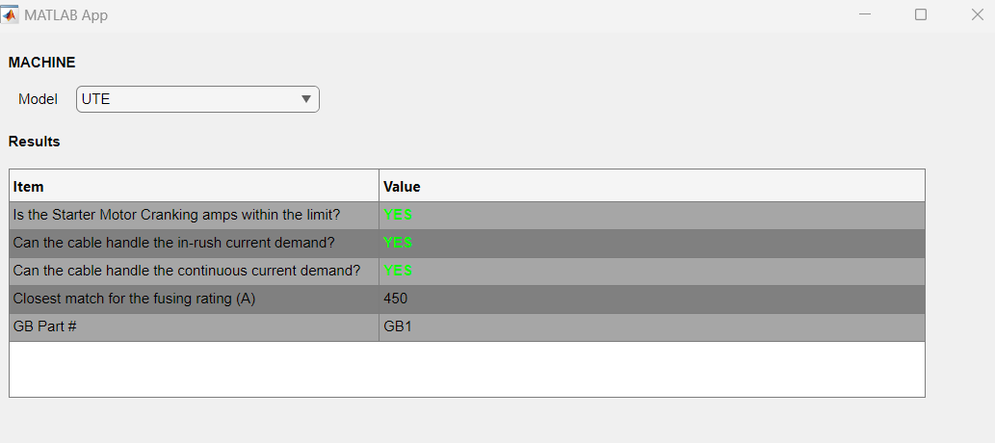
% Value changed function: ModelDropDown
function ModelDropDownValueChanged(app, event)
%% TO DISPLAY MANUFACTURER AND CRANKING CURRENT %%
% Model name
selectedModel = app.ModelDropDown.Value;

%% Model column data
excelFilePath = 'C:\Users\BlossomFernandez\GB AUTO GROUP PTY LIMITED\DVT - Document\Projects\Simulink & MATLAB\Projects\APP_Fuse\Fuse_GUI.xlsx';

%% Define the sheet name
% MachineOnSite Sheet
sheetNameMachinesOnSite = 'MachinesOnSite';
% Fuse Library Sheet
sheetNameFuseLibrary = 'Fuse_Library';

%% Read the header from the second row
% MachineOnSite Sheet
headerDataMachinesOnSite = readcell(excelFilePath, 'Sheet', sheetNameMachinesOnSite, 'Range', 'A2:X2');
% Fuse Library Sheet
headerDataFuseLibrary = readcell(excelFilePath, 'Sheet', sheetNameFuseLibrary, 'Range', 'A1:K1');

%% Read the actual data starting from the third row
% MachineOnSite Sheet
dataMachinesOnSite = readtable(excelFilePath, 'Sheet', sheetNameMachinesOnSite, 'Range', 'A3:X1000'); % Adjust range as needed
% Fuse Library Sheet
dataFuseLibrary = readtable(excelFilePath, 'Sheet', sheetNameFuseLibrary, 'Range', 'A2:K20'); % Adjust range as needed

%% Clean headers by removing line breaks and extra whitespace
% MachineOnSite Sheet
cleanedHeaderDataMachinesOnSite = regexprep(headerDataMachinesOnSite, '[\n\r]+', ''); % Remove line breaks
cleanedHeaderDataMachinesOnSite = strtrim(cleanedHeaderDataMachinesOnSite); % Trim leading/trailing spaces
% Fuse Library Sheet
cleanedHeaderDataFuseLibrary = regexprep(headerDataFuseLibrary, '[\n\r]+', ''); % Remove line breaks
cleanedHeaderDataFuseLibrary = strtrim(cleanedHeaderDataFuseLibrary); % Trim leading/trailing spaces

%% Assign cleaned column names to the table
% MachineOnSite Sheet
dataMachinesOnSite.Properties.VariableNames = cleanedHeaderDataMachinesOnSite;
% Fuse Library Sheet
dataFuseLibrary.Properties.VariableNames = cleanedHeaderDataFuseLibrary;

%% Access the Column
% MachineOnSite Sheet
modelColumn = dataMachinesOnSite.Model;

% Fuse Library Sheet
FuseRatingColumn = dataFuseLibrary.('Current rating (A)') ;
ThermalEnergyColumn = dataFuseLibrary.('I2t (A2s)');
GBPartNumberColumn = dataFuseLibrary.('GB PART #');

%% Perform index matching to find the selected model
rowIndexMachinesOnSite = find(ismember(modelColumn, selectedModel), 1);

%% Initialize Values
CrankingAmpsHighorLow = 'Data Unavailable'; % Default value

if ~isempty(rowIndexMachinesOnSite)
%% Assign Column Names from data table
StarterMotorCrankingCurrentColumnName = 'Starter Motor Peak Current (A)';
CrankingTimeColumnName = 'Cranking time (s)';
CableSizeColumnName = 'Cable Size(mm2)';
AlternatorContinuousCurrentColumnName = 'Alternator Continuous Current (A)';
CableContinuousCurrentColumnName = 'Continuous Current (A)';

%% Assign Data
FusingSafetyCurrentFactor = 125/100;
KFactorCopper = 143;

%% Extract the values in the respective column
StarterMotorCrankingCurrentValue = dataMachinesOnSite{rowIndexMachinesOnSite, StarterMotorCrankingCurrentColumnName}; % Cranking current at 1000A
CrankingTimeValue = dataMachinesOnSite{rowIndexMachinesOnSite, CrankingTimeColumnName}; % Cranking Time
CableSizeValue = dataMachinesOnSite{rowIndexMachinesOnSite, CableSizeColumnName}; % Cable Size
AlternatorContinuousCurrentValue = dataMachinesOnSite{rowIndexMachinesOnSite, AlternatorContinuousCurrentColumnName}; % Alternator Continuous Current
CableContinuousCurrentValue = dataMachinesOnSite{rowIndexMachinesOnSite, CableContinuousCurrentColumnName}; % Cable Continuous Current

%% Apply the function to convert values
StarterMotorCrankingCurrentValue = app.convertValue(StarterMotorCrankingCurrentValue);
CrankingTimeValue = app.convertValue(CrankingTimeValue);
CableSizeValue = app.convertValue(CableSizeValue);
AlternatorContinuousCurrentValue = app.convertValue(AlternatorContinuousCurrentValue);
CableContinuousCurrentValue = app.convertValue(CableContinuousCurrentValue);
GBPartNumberColumn = app.convertValue(GBPartNumberColumn);

%% Debugging: Print the class of the converted value
% disp(['Class of StarterMotorCrankingCurrentValue: ', class(StarterMotorCrankingCurrentValue)]);
% disp(['Class of CrankingTimeValue: ', class(CrankingTimeValue)]);
% disp(['Class of CableSizeValue: ', class(CableSizeValue)]);
% disp(['Class of AlternatorContinuousCurrentValue: ', class(AlternatorContinuousCurrentValue)]);
% disp(['Class of CableContinuousCurrentValue: ', class(CableContinuousCurrentValue)]);

%% Check if parameter is 'Data Unavailable' or another string like 'TBC'

%Is the cranking current less than the max (1000A) value?

if ischar(StarterMotorCrankingCurrentValue) || isstring(StarterMotorCrankingCurrentValue)
% Handle cases where the value is 'Data Unavailable', 'TBC', etc.
if strcmp(StarterMotorCrankingCurrentValue, 'Data Unavailable') || strcmp(StarterMotorCrankingCurrentValue, 'TBC')
CrankingAmpsHighorLow = 'Data Unavailable';
end
elseif isnumeric(StarterMotorCrankingCurrentValue)

% If it's numeric, compare it
if StarterMotorCrankingCurrentValue <= 1000
CrankingAmpsHighorLow = 'YES'; % Cranking current is <= 1000A
else
CrankingAmpsHighorLow = 'NO, Cranking amps over the limit, replace the starter motor'; % Cranking current is greater than 1000A
end
else
% Handle unexpected data types
CrankingAmpsHighorLow = 'Invalid Data';
end
end

%% Check if the parameter is 'Data Unavailable' or another string like 'TBC'

%Can the cable handle the in-rush current demand?

if ischar(CrankingTimeValue) || isstring(CrankingTimeValue) || ischar(CableSizeValue) || isstring(CableSizeValue)
% Handle cases where the value is 'Data Unavailable', 'TBC', etc.
if strcmp(CrankingTimeValue, 'Data Unavailable') || strcmp(CrankingTimeValue, 'TBC') || strcmp(CableSizeValue, 'Data Unavailable') || strcmp(CableSizeValue, 'TBC')

CablePeakCurrent = 'Data Unavailable';
end

elseif isnumeric(CrankingTimeValue) && isnumeric(CableSizeValue)

% If it's numeric, compare it
if CrankingTimeValue <= 5
CablePeakCurrent = ((KFactorCopper*CableSizeValue)/ sqrt (CrankingTimeValue)) ;
else
CablePeakCurrent = ['Cables unable handle peak current beyond 5s, ' ...
'investigate electrical component that needs servicing'];
end
else
% Handle unexpected data types
CablePeakCurrent = 'Invalid Data';
end

%% Can the cable handle the in-rush current demand?

if ischar(StarterMotorCrankingCurrentValue) || isstring(StarterMotorCrankingCurrentValue) || ischar(CablePeakCurrent) || isstring(CablePeakCurrent)
% Handle cases where the value is 'Data Unavailable', 'TBC', etc.
if strcmp(StarterMotorCrankingCurrentValue, 'Data Unavailable') || strcmp(StarterMotorCrankingCurrentValue, 'TBC') || strcmp(CablePeakCurrent, 'Data Unavailable') || strcmp(CablePeakCurrent, 'TBC')

CablePeakHandlingCapability = 'Data Unavailable';
end

elseif isnumeric(StarterMotorCrankingCurrentValue) && isnumeric(CablePeakCurrent)

% If it's numeric, compare it
if StarterMotorCrankingCurrentValue <= CablePeakCurrent
CablePeakHandlingCapability = 'YES';
else
CablePeakHandlingCapability = 'NO, Change the cable to one size up;
end
else
% Handle unexpected data types
CablePeakHandlingCapability = 'Invalid Data';
end

%% Can the cable handle the continuous current demand?

if ischar(AlternatorContinuousCurrentValue) || isstring(AlternatorContinuousCurrentValue) || ischar(CableContinuousCurrentValue) || isstring(CableContinuousCurrentValue)
% Handle cases where the value is 'Data Unavailable', 'TBC', etc.
if strcmp(AlternatorContinuousCurrentValue, 'Data Unavailable') || strcmp(AlternatorContinuousCurrentValue, 'TBC') || strcmp(CableContinuousCurrentValue, 'Data Unavailable') || strcmp(CableContinuousCurrentValue, 'TBC')

CableContiHandlingCapability = 'Data Unavailable';
end

elseif isnumeric(AlternatorContinuousCurrentValue) && isnumeric(CableContinuousCurrentValue)

% If it's numeric, compare it
if AlternatorContinuousCurrentValue <= CableContinuousCurrentValue
CableContiHandlingCapability = 'YES';
else
CableContiHandlingCapability = 'NO, Change the cable to one size up
';
end
else
% Handle unexpected data types
CableContiHandlingCapability = 'Invalid Data';
end
%% Fuse Current Rating (A) calculation

if strcmp(CableContiHandlingCapability, 'YES')
FuseCurrentRatingCalculation = FusingSafetyCurrentFactor * CableContinuousCurrentValue;
else
FuseCurrentRatingCalculation = 'Data Unavailable';

end

%% Closest Fuse Match Calculation

% Check if FuseCurrentRating is available and numeric
if isnumeric(FuseCurrentRatingCalculation)
% Calculate the absolute difference between the Fuse options and the current rating
diff = abs(FuseRatingColumn - FuseCurrentRatingCalculation);

% Find the index of the minimum difference
[~, idx] = min(diff); %The first output is the minimum value itself. The second output is the index of that minimum value in the array.

% If an index is found, get the closest fuse match
if ~isempty(idx)
FuseClosestMatch = FuseRatingColumn(idx);
else
FuseClosestMatch = 'Data Unavailable';
end
else
FuseClosestMatch = 'Data Unavailable';
end

%% Fuse Thermal Energy Calculation

% Check if FuseCurrentRating is available and numeric
if isnumeric(StarterMotorCrankingCurrentValue) && isnumeric(CrankingTimeValue) && strcmp(CrankingAmpsHighorLow, 'YES')
% Calculate the absolute difference between the Fuse options and the current rating
RequiredThermalEnergy = (StarterMotorCrankingCurrentValue)^2 * CrankingTimeValue;
else
RequiredThermalEnergy = 'Data Unavailable';
end

%% Thermal Energy Match Calculation

if isnumeric(RequiredThermalEnergy) && isnumeric(FuseClosestMatch)
% Extract Thermal Energy Column from the table

% Perform logical indexing to filter the values
validRows = (FuseRatingColumn == FuseClosestMatch) & (ThermalEnergyColumn > RequiredThermalEnergy);

% Check if there are valid matches
matchingThermalEnergy = ThermalEnergyColumn(validRows);

if ~isempty(matchingThermalEnergy)
% Return the first match
ThermalEnergyMatch = matchingThermalEnergy(1);
else
% No valid match found
ThermalEnergyMatch = 'NO MATCH';
end
else
% If data is not available
ThermalEnergyMatch = 'Data Unavailable';
end
%% Match GB Part #

% Assume the columns are already loaded into variables:
% GBPartNumberColumn, ThermalEnergyColumn, FuseRatingColumn, ThermalEnergyMatch, FuseClosestMatch

% Find rows where both conditions are true
matchingRows = (ThermalEnergyColumn == ThermalEnergyMatch) & (FuseRatingColumn == FuseClosestMatch);

% Find the first matching row
rowIndex = find(matchingRows, 1);

% Retrieve the corresponding value from GBPartNumberColumn
if ~isempty(rowIndex)
GBPartNumberValue = GBPartNumberColumn(rowIndex);
else
GBPartNumberValue = 'Data Unavailable'; % Handle the case when no match is found
end

% Display the result
disp(['GBPartNumberValue: ', num2str(GBPartNumberValue)]);

%% Debugging:
% disp(['FuseClosestMatch: ', num2str(FuseClosestMatch)]);
% disp(['RequiredThermalEnergy: ', num2str(RequiredThermalEnergy)]);
% disp(['ThermalEnergyMatch: ', num2str(ThermalEnergyMatch)]);
% disp(['GBPartNumber: ',char(GBPartNumberValue)]);
%disp(['Class of FuseCurrentRatingValue: ', class(FuseCurrentRatingValue)]);
% disp(['StarterMotorCrankingCurrentValue: ', num2str(StarterMotorCrankingCurrentValue)]);
% disp(['CrankingTimeValue: ', num2str(CrankingTimeValue)]);
% disp(['CableSizeValue: ', num2str(CableSizeValue)]);
% disp(['AlternatorContinuousCurrentValue: ', num2str(AlternatorContinuousCurrentValue)]);
% disp(['CableContinuousCurrentValue: ', num2str(CableContinuousCurrentValue)]);
% disp(['Is cranking current <= 1000A: ', num2str(CrankingAmpsHighorLow)]);
% disp(['Peak/short circuit current carrying capability (A) ', num2str(CablePeakCurrent)]);
% disp(['CablePeakHandlingCapability ', num2str(CablePeakHandlingCapability)]);
% disp(['CableContiHandlingCapability ', num2str(CablePeakHandlingCapability)]);
% disp(['FuseCurrentRating ', num2str(FuseCurrentRatingCalculation)]);
% disp(['FuseClosestMatch ', num2str(FuseClosestMatch)]);
% disp(['RequiredThermalEnergy ', num2str(RequiredThermalEnergy)]);

%% Set UITable Data
tableData = {
'Is the Starter Motor Cranking amps within the limit?', CrankingAmpsHighorLow;
'Can the cable handle the in-rush current demand?', CablePeakHandlingCapability;
'Can the cable handle the continuous current demand?', CableContiHandlingCapability;
'Closest match for the fusing rating (A)', FuseClosestMatch;
'GB Part #', char(GBPartNumberValue); % Convert non-text values to char
};

% Set the table data in the UITable
app.UITable.Data = tableData;

%% Define a function to apply styles based on cell values
function applyStyles(app, row, col, fontColor, fontWeight)
style = uistyle;
style.FontColor = fontColor; % Set font color
style.FontWeight = fontWeight; % Set font weight

% Apply the style to the specific cell
addStyle(app.UITable, style, 'cell', [row, col]);
end

%% Define a function to apply alignment
function applyAlignment(app, row, col, hAlign)
alignStyle = uistyle;
alignStyle.HorizontalAlignment = hAlign; % Set horizontal alignment

% Apply the alignment style to the specific cell
addStyle(app.UITable, alignStyle, 'cell', [row, col]);
end

%% Iterate through each column and apply styles based on content
for col = 1:size(tableData, 2)

% First Row - CrankingAmpsHighorLow
if isstring(tableData{1, col}) || ischar(tableData{1, col})
switch tableData{1, col}
case 'Data Unavailable'
applyStyles(app, 1, col, 'yellow', 'bold');
case 'YES'
applyStyles(app, 1, col, 'green', 'bold');
case 'NO, Cranking amps over the limit, replace the starter motor'
applyStyles(app, 1, col, 'red', 'bold');
case 'Invalid Data'
applyStyles(app, 1, col, 'gray', 'bold');
otherwise
applyStyles(app, 1, col, 'black', 'normal');
end
elseif isnumeric(tableData{1, col})
applyStyles(app, 1, col, 'black', 'normal'); % Numeric values should be black
end
applyAlignment(app, 1, col, 'left'); % Left-align

% Second Row - CablePeakHandlingCapability
if isstring(tableData{2, col}) || ischar(tableData{2, col})
switch tableData{2, col}
case 'Data Unavailable'
applyStyles(app, 2, col, 'yellow', 'bold');
case 'YES'
applyStyles(app, 2, col, 'green', 'bold');
case 'NO, Change the cable to one size up
'
applyStyles(app, 2, col, 'red', 'bold');
case 'Invalid Data'
applyStyles(app, 2, col, 'gray', 'bold');
otherwise
applyStyles(app, 2, col, 'black', 'normal');
end
elseif isnumeric(tableData{2, col})
applyStyles(app, 2, col, 'black', 'normal'); % Numeric values should be black
end
applyAlignment(app, 2, col, 'left'); % Left-align

% Third Row - CableContiHandlingCapability
if isstring(tableData{3, col}) || ischar(tableData{3, col})
switch tableData{3, col}
case 'Data Unavailable'
applyStyles(app, 3, col, 'yellow', 'bold');
case 'YES'
applyStyles(app, 3, col, 'green', 'bold');
case 'NO, Change the cable to one size up
'
applyStyles(app, 3, col, 'red', 'bold');
case 'Invalid Data'
applyStyles(app, 3, col, 'gray', 'bold');
otherwise
applyStyles(app, 3, col, 'black', 'normal');
end
elseif isnumeric(tableData{3, col})
applyStyles(app, 3, col, 'black', 'normal'); % Numeric values should be black
end
applyAlignment(app, 3, col, 'left'); % Left-align

% Fourth Row - FuseClosestMatch
if isstring(tableData{4, col}) || ischar(tableData{4, col})
switch tableData{4, col}
case 'Data Unavailable'
applyStyles(app, 4, col, 'yellow', 'bold');
case 'YES'
applyStyles(app, 4, col, 'green', 'bold');
case 'NO'
applyStyles(app, 4, col, 'red', 'bold');
case 'Invalid Data'
applyStyles(app, 4, col, 'gray', 'bold');
otherwise
applyStyles(app, 4, col, 'black', 'normal');
end
elseif isnumeric(tableData{4, col})
applyStyles(app, 4, col, 'black', 'normal'); % Numeric values should be black
end
applyAlignment(app, 4, col, 'left'); % Left-align

% Fifth Row - GBPartNumberValue
if isstring(tableData{5, col}) || ischar(tableData{5, col})
switch tableData{5, col}
case 'Data Unavailable'
applyStyles(app, 5, col, 'yellow', 'bold');
case 'YES'
applyStyles(app, 5, col, 'green', 'bold');
case 'NO'
applyStyles(app, 5, col, 'red', 'bold');
case 'Invalid Data'
applyStyles(app, 5, col, 'gray', 'bold');
otherwise
applyStyles(app, 5, col, 'black', 'normal');
end
elseif isnumeric(tableData{5, col})
applyStyles(app, 5, col, 'black', 'normal'); % Numeric values should be black
end
applyAlignment(app, 5, col, 'left'); % Left-align

end

end
%% Function to check type and convert values
function output = convertValue(~, val)
if iscell(val) % If it's a cell array
val = val{1}; % Extract the first element
end

% Handle different data types
if isnumeric(val)
output = val; % If numeric, leave it as is
elseif ischar(val) || isstring(val)
output = str2double(val); % Convert char or string to numeric if possible
if isnan(output)
output = string(val); % If conversion to numeric fails, convert to string
end
else
output = val; % If some other type, leave it unchanged (or handle as needed)
end

end
end

